**NetCampus -ERP**

**Library**

This module manages and track all the librarian work for the students such as Book availability, search for any book, issued book, returned book history of any particular user and book requisition list

This module consists of three sub modules which are as follows: -

1. **Book Requisition List**

In this sub module you can request for a particular book by searching it through its book title, Author and Publisher

Figure shows the Book Requisition List front screen

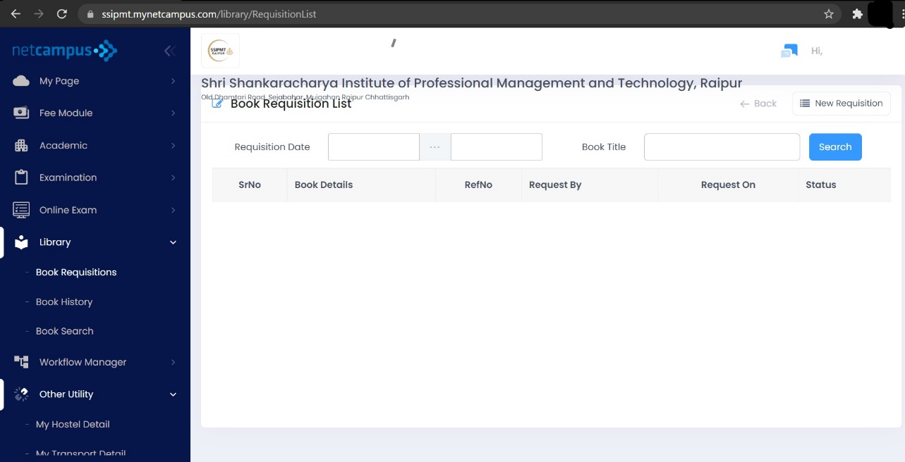

In this module,

User can see all those book list for which you have requested and can also search it by its date and title by entering the details and then clicking on the search option

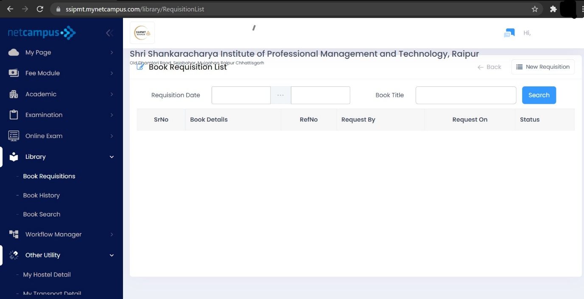

Or can request for the book via New Requisition option present on the screen

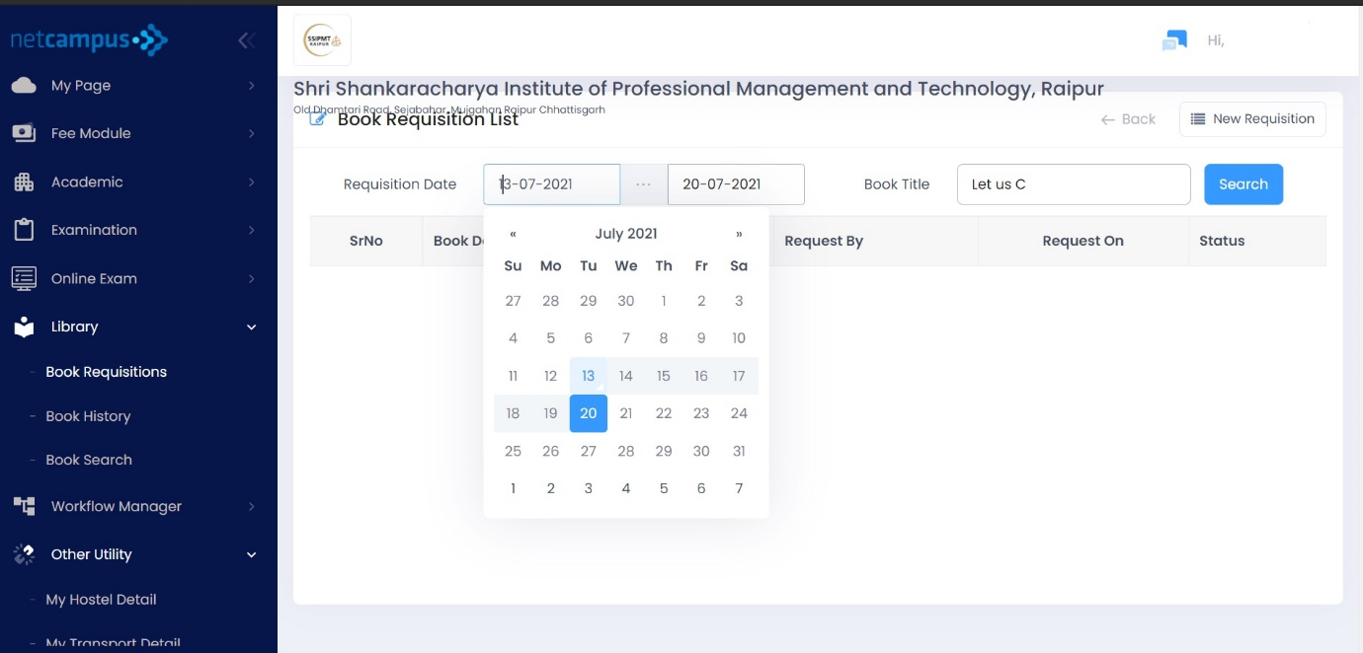

For searching your requested book below steps can be followed

Step 1: -

Click on the Requisition date and edit the date from which-to-which date user requested for the book



Step 2:-

Select the book title and then click on the search button after clicking the list will be displayed on the below area

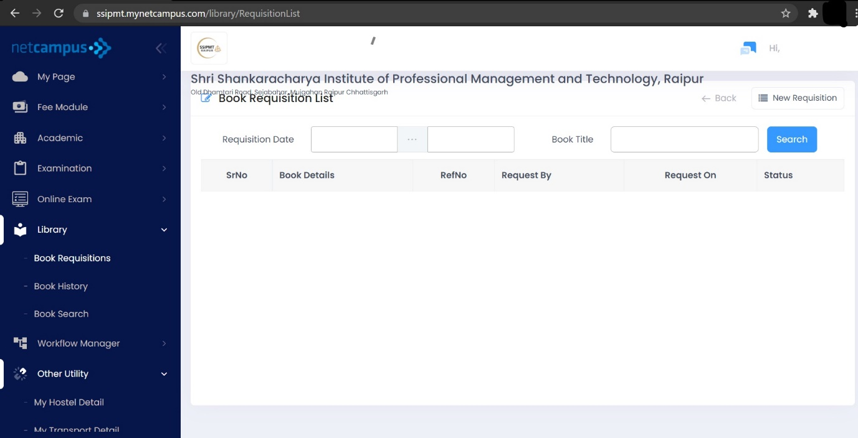

For new request after clicking on new requisition the below screen will appear where user can write the book title, author of the book or publisher and can search for the availability of any particular book

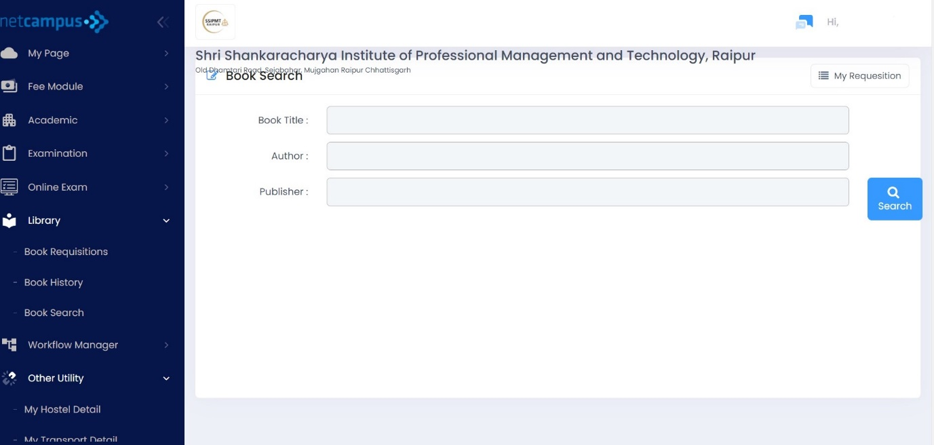

Step 1 :-

Write the book title, author of the book or publisher as shown in the figure

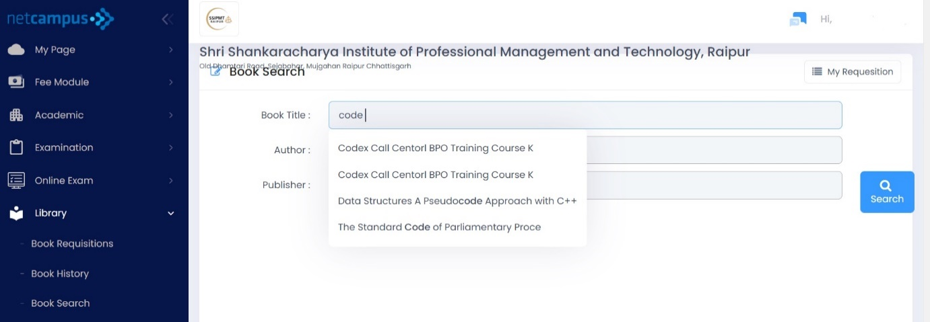

Step 2: - After step 1 click on the search option to see the availability of the book



Step 3:-

After following step 1 and step 2 the list of searched books will be displayed with its quantity like total books available, total book issued and also the total quantity of books present on the library as shown in the figure

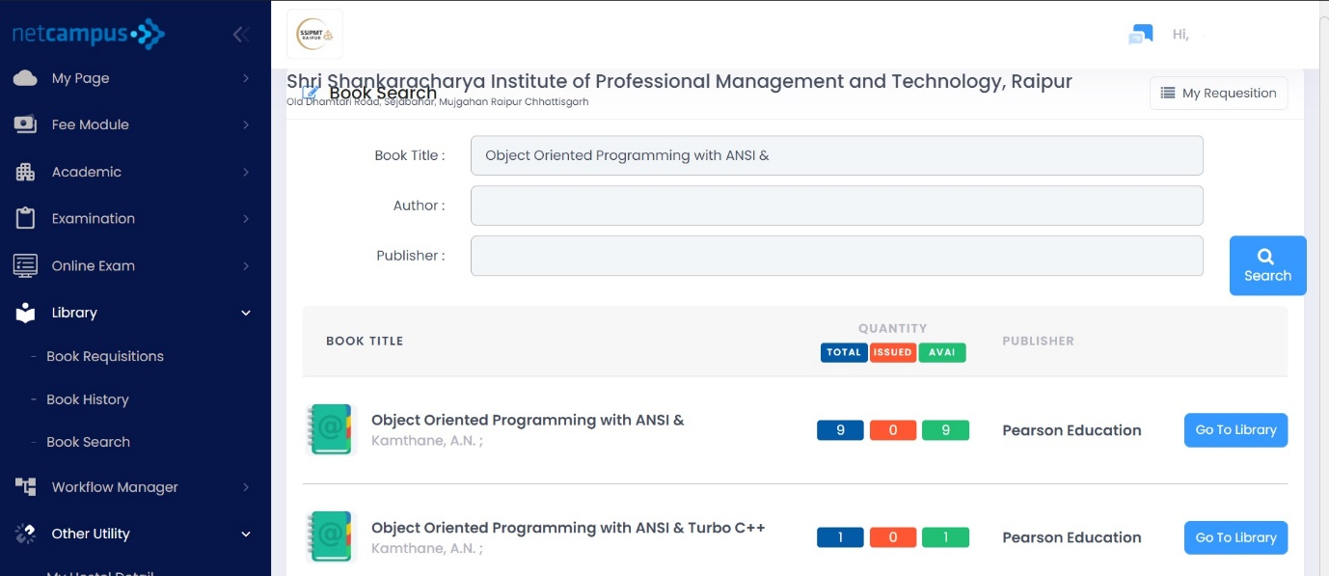

1. **Book History**

This sub module will display the list of books which are issued to the particular student and also the history of all the book which are returned by the user to the library as shown in the figure

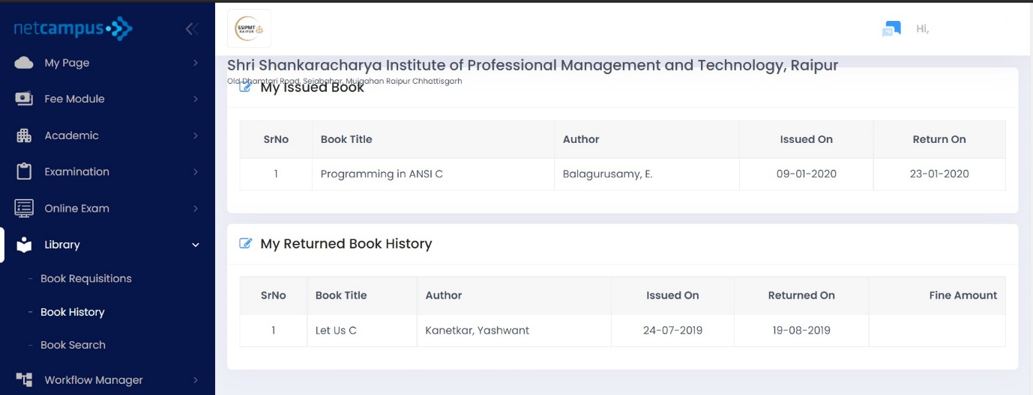

1. **Book Search**

Here in this sub module user can search for any particular book by its title, author or publisher



Step 1:- user should enter any of the specific field or all the fields such as book title, author or publisher

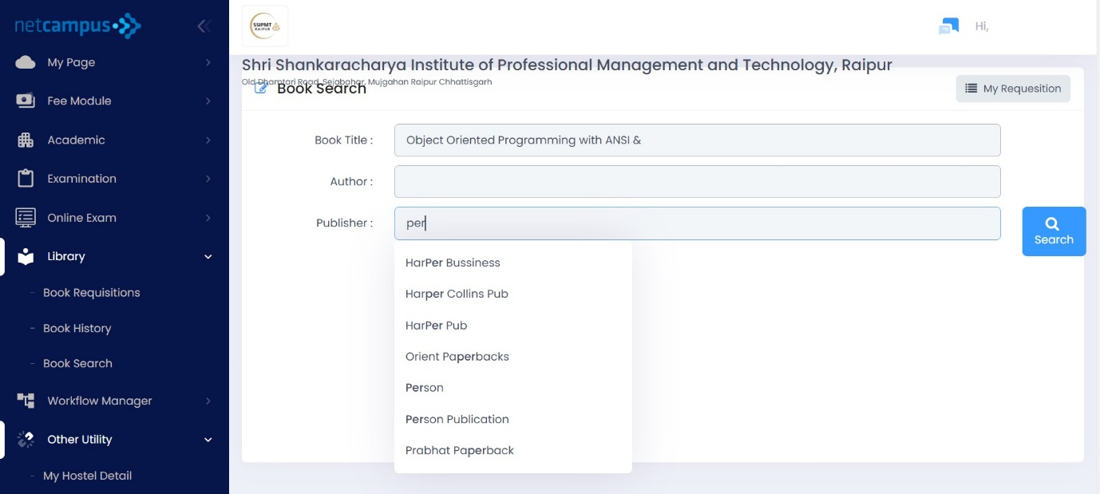

Step 2: - after entering , click on the search option

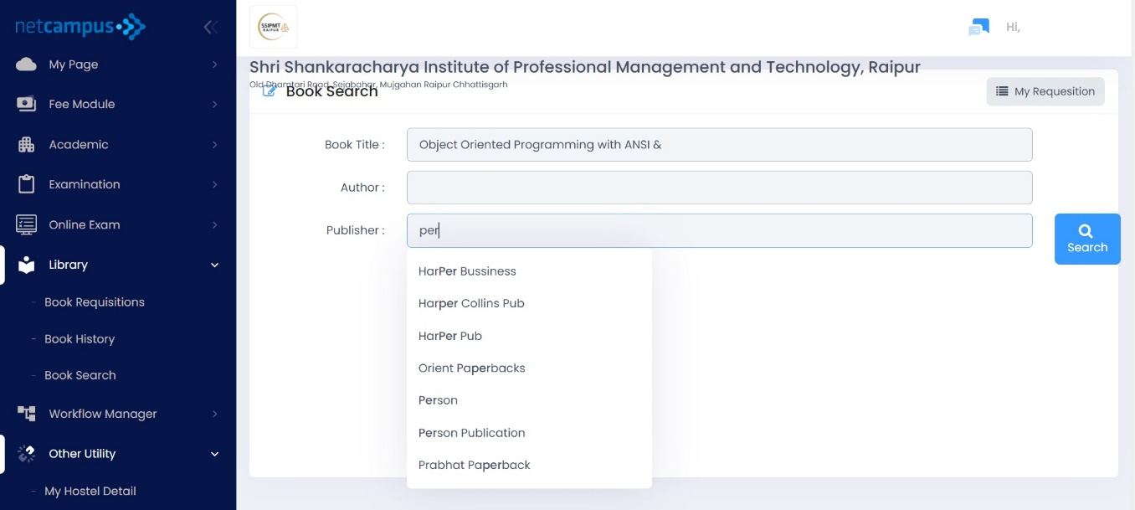

Step 3: - after clicking on search button, it will display the list of available book which the user has searched for with its quantity

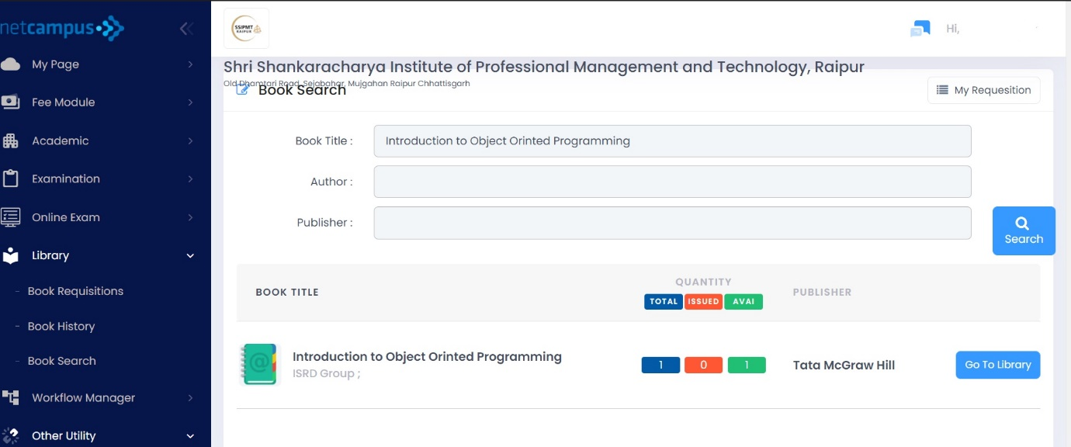

Or

There is an option named as My Requisition which will display the list of books which is issued to the user and also history of books which are returned by the user as shown in the figure





**Other utility**

This module manages and let the student know their hostel and transport details

This module consists of two sub modules which are: -

1. **My Hostel details**

It will display whether the student has taken the hostel or not

If not taken the hostel facility it will display the text **Hostel Facility not taken**!! As shown in the figure

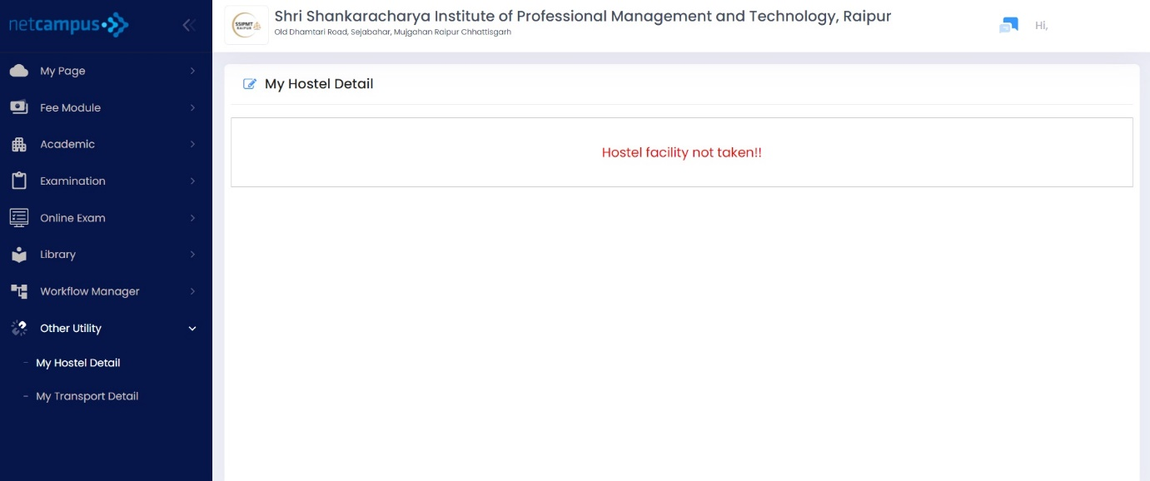

If hostel facility is taken by the student, then the details like Hostel and Room details will be displayed as shown in the figure

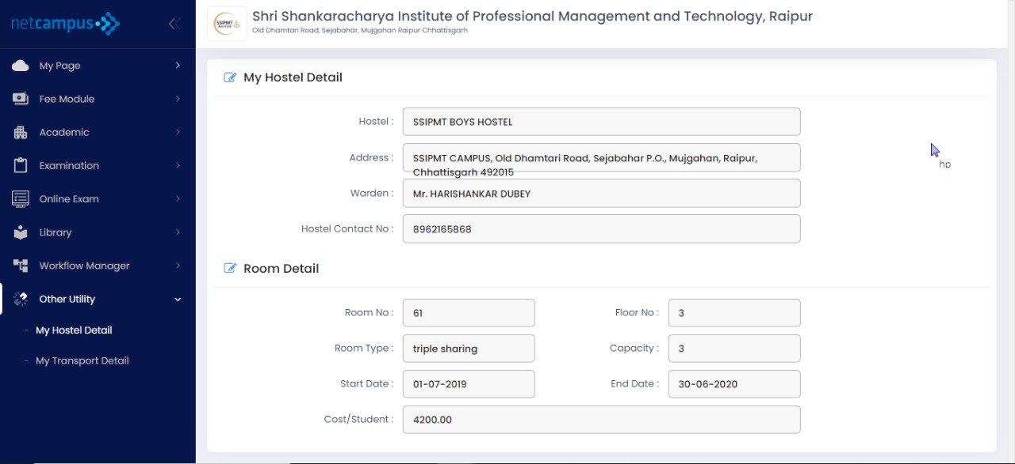

1. **My Transport details**

It will display whether the student has taken the transport facility or not

If not taken the transport facility it will display the text **Transport Facility not taken**!! As shown in the figure

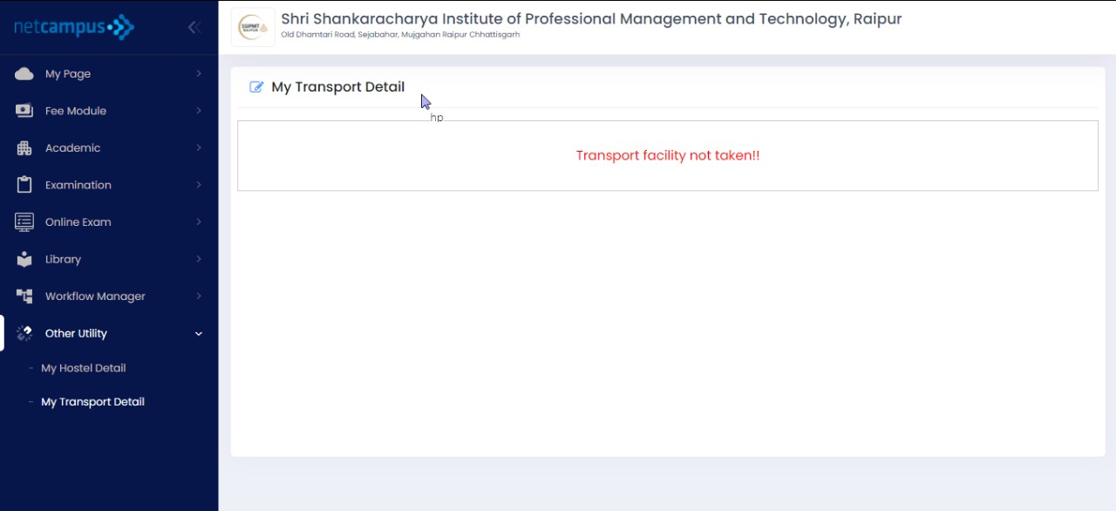

If transport facility is taken by the student, then the details like Transport details and pick & drop details will be displayed as shown in the figure

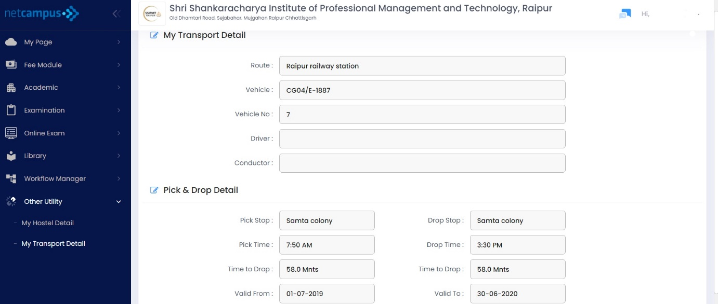

**Password Manager**

This section will help students to change or recover their password

**Password Recovery**

first enter Current Password or if don’t remember password then can go for forget password option to recover password

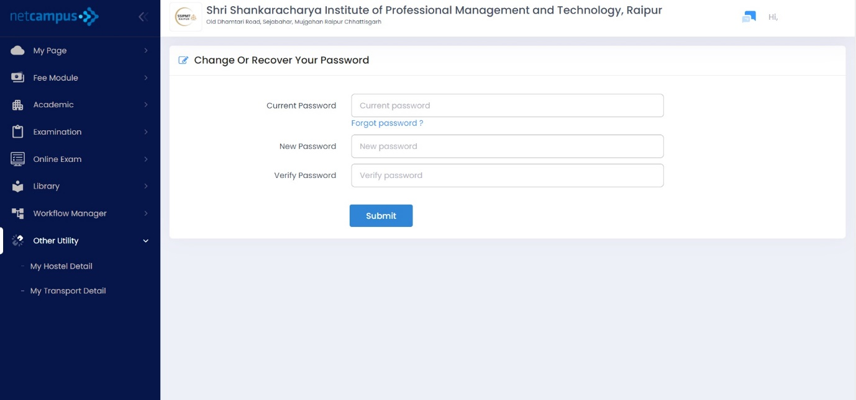

Change Password

Step 1:-

enter current password and then enter the new password after that reenter the new password in the verify password area and then click on the submit button



Step 2:-

After clicking on submit button a message displays that password changes successfully as shown in the figure

